**How to install apks to Android TV through ADB**

1. **Let your PC support ADB: Copy adb.exe and AdbWinApi.dll to your PC’s following directory:**
   1. C:\windows\system32. 32bit windows, copy to a is ok.
   2. C:\Windows\SysWOW64. 64bit windows, please copy to both a and b.
2. **Connect your TV and PC to the same router.**

Get TV ‘s IP address:TV Settings🡪Network🡪Ethernet/Wireless settings🡪Information.

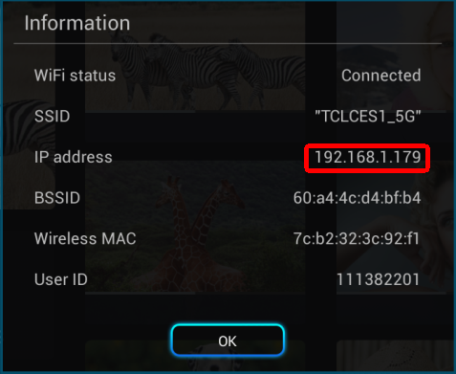

1. **Get your Android TV ready for ADB connection(MS801,901,RT92,95)**
2. Click TCPUDPDebug\TCPUDPDbg.exe and open it(From PC, this tool is included in package).
3. Click “CreateConn” button and input DestIP and port as following:

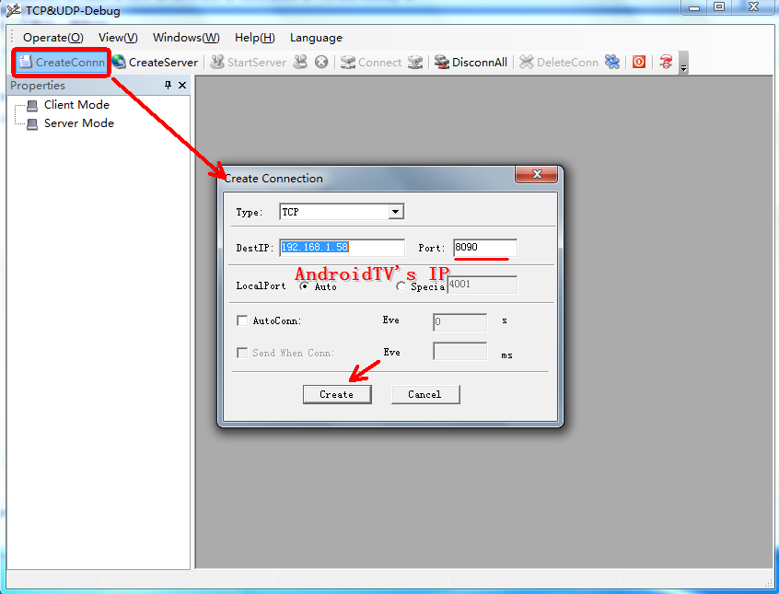

1. After Click “Create”, you will see the following page, then click connect:

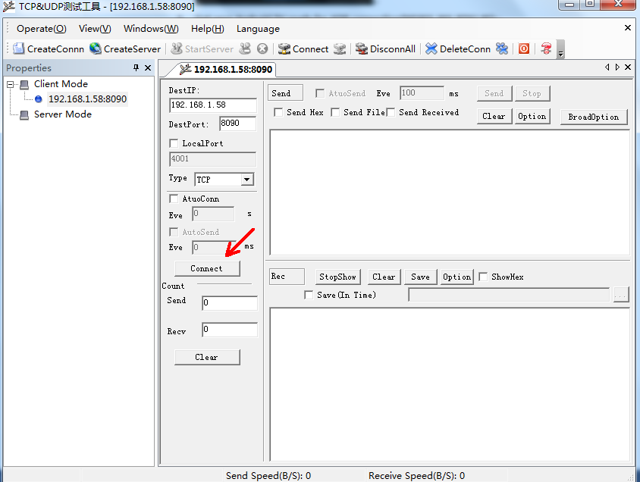

1. After Click “Connect”, if the “Connect” button become to “Disconect”, this shows you successfully connect to your TV. Then you can input “start adbd” as following, and click “Send” button send it to your TV. If you see “ok” appears at the bellow text area, your ADB is started and your TV is ready for adb connection.

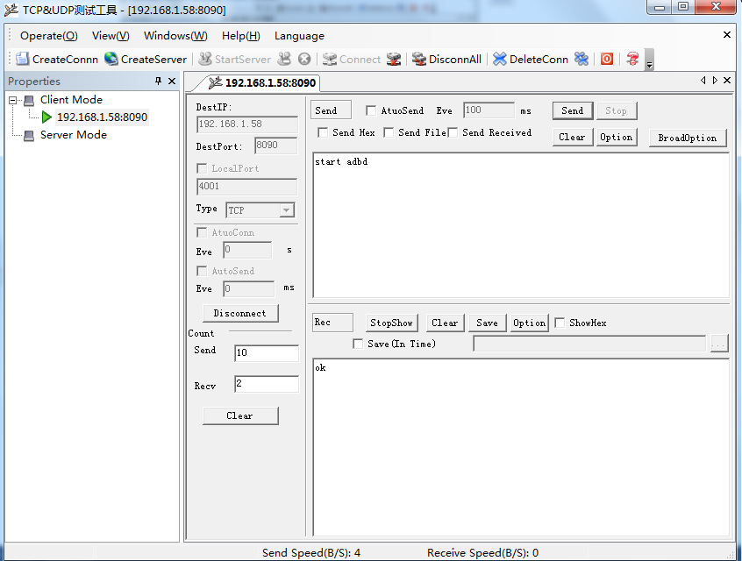

1. **Open a CMD window in your PC(Press “+R”, input “cmd”, then press “Enter”), and run the following command in the CMD window:**

>adb connect 192.168.1.xx *192.168.1.xx is your TV’s IP address*

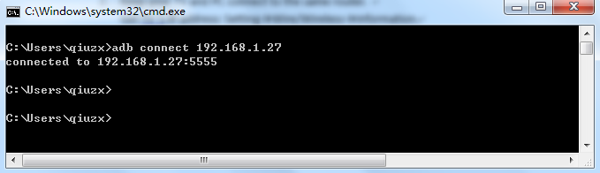

1. **Drag your apks (Support multi-apks) to adb_install_apks.bat, then wait the installation process finished.**

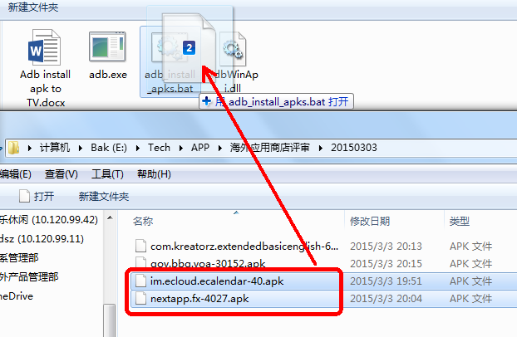

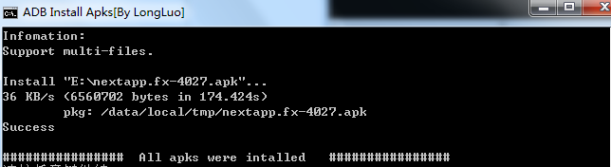

1. **Select your TV’s “My Apps” and press “OK” button, you will see the newly installed apps.**